ComfortRead

Improves readability of text to reduce eyestrain and difficulty focusing

## Team “Creative Team Name”

Jayden LeCorps

Ben Yandell

Nathan Green

Joshua Lopez

Sean Whynot

# Problem

Students with learning disabilities such as dyslexia and ADHD can suffer in reading comprehension causing them to struggle in classes or work. The article Reading Comprehension and Executive Function put it best by stating that, “when a student loses comprehension during a reading—misreads a sentence, for example—they will abandon the attempt to understand the text. As they continue to read, they pay less attention to accuracy. It’s as if once they fall off the rails, they don’t recover” (Debbie Tracht - <https://chadd.org/adhd-news/adhd-news-educators/reading-comprehension-and-executive-function/>). Readers can help remedy this issue with tools such as Google's built in text to speech as it forces the reader to slow down and follow along, reducing the possibility of a reader with dyslexia to lose their place or a reader with ADHD to read too fast. However, these solutions may not account for those with additional disabilities such as deafness or hard of hearing, or the reader could be in a situation where they can’t listen without disturbing others in public. Since a big issue with readers that have ADHD and dyslexia is reading comprehension, how can we keep readers engaged, reading at their own pace, and following along with the text accurately and attentively?

# Prior Solutions

## DarkReader (Replace with [Speechify](https://speechify.com/blog/text-to-speech-dyslexia/) (Dyslexia Aid))

[DarkReader](https://r.search.yahoo.com/_ylt=AwrhdokX4AVnX_0Coz5XNyoA;_ylu=Y29sbwNiZjEEcG9zAzEEdnRpZAMEc2VjA3Ny/RV=2/RE=1729647896/RO=10/RU=https%3a%2f%2fdarkreader.org%2f/RK=2/RS=cHD6v.e0EFwce668T9L0o.Ml4eA-) is a browser extension that replaces the bright elements in a website with darker colors, and replaces the text with brighter colors. This helps provide eye comfort for people with brightness sensitivity, or for night viewing.

Our application will not be a browser extension, but a web application that users can paste text into from any source. It will also allow font customization and highlighting.



Where Darkreader can do the below (for example, showing the figure above when Darkreader is on), our app will similarly do X but not Y.

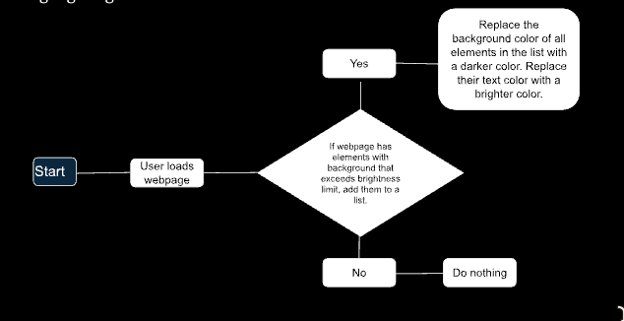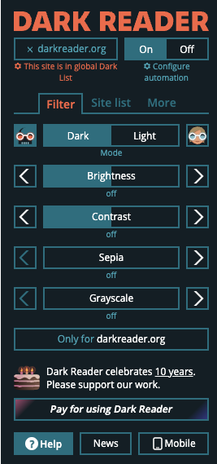

## EasyReading

The [EasyReading Font](https://r.search.yahoo.com/_ylt=AwrFYp684AVnhkoDephXNyoA;_ylu=Y29sbwNiZjEEcG9zAzEEdnRpZAMEc2VjA3Ny/RV=2/RE=1729648060/RO=10/RU=https%3a%2f%2fwww.easyreading.it%2fen%2f/RK=2/RS=r9ReOZm1QNCsphnnHzUQ4v88IbI-) is a “high-legibility typeface”, a font designed for readers with dyslexia. It uses a custom mix of serif and sans serif letters to aid in letter recognition. It is similar to our app in that its purpose is to make reading easier for people who have difficulty with the readability of text by changing visual aspects of the text.  
([Reference](https://www.easyreading.it/wp-content/uploads/2017/03/bachmann_-scientific_study.pdf) - Dyslexia. Italian Journal of Clinical and Applied Research by Christina Bachmann)

The EasyReading Font is something that you need to download, install, and choose as the font in whatever program you are using. Our app will be an online page that you do not need to download and install. The EasyReading Font only addresses text readability in one way (choosing a good font). Our app will address text readability in multiple ways (choosing a good font, changing interletter and interword spacing, bolding specific letters in a word, etc). For example we will use a feature called “[Bionic Reading](https://theglowstudio.com/what-is-bionic-reading/#:~:text=Some%20people%20who%20suffer%20from,any%20better%20than%20regular%20text.)”. The method emphasizes key parts of words—typically the first few letters—while allowing the rest of the text to be read normally. This approach aims to guide the reader's focus and improve retention, particularly for individuals with reading difficulties, such as dyslexia.



## Accessibility Tools (Safari/Chrome)

Web browsers such as Safari and Google Chrome offer various accessibility tools for readers to use such as, text-to-speech, live captioning, voice typing, screen reading and more. However, these often are very inconsistent between different operating systems (MacOS/Windows) which can negatively affect the user’s experience and limit what is available. Another issue is causing cognitive overload for those who need to have other extensions open in order to aid focus/retention when reading.  
[Research](https://www.npr.org/2008/10/02/95256794/think-youre-multitasking-think-again) indicates that when users have numerous tabs or extensions open, they tend to experience "task switching," which can lead to diminished focus and increased cognitive load. This behavior can contribute to mental fatigue, as users may feel overwhelmed by the need to manage multiple extensions while trying to concentrate on reading or other tasks

Our application will allow personalized customization and is dedicated to aiding user experience without the hassle of managing other extensions or applications. Our application will also most likely not target as many types of users needing accessibility as Accessibility Tools is able to help a broad range of people such as hearing needs, sight impairments, and more while we will be mostly focusing on ADHD and dyslexia. For example ComfortRead will have the option to go distraction-free by hiding all controls and formatting options. As well as have an option for text to speech that can be set to different reading speeds.



# Our App: ComfortRead

ComfortRead is a website which will provide a wide variety of accessibility features for those who have ADHD, Dyslexia, or those who struggle with reading comprehension online. With ComfortRead, Users will be able to type or paste in text they desire to read. After entering text, ComfortRead will offer features to help with focus and reading comprehension such as Dark Mode, text to speech, summaries, clear fonts, and clear formatting. These features will allow users to more easily follow along and read online to avoid distractions such as bad formatting, hard to read fonts, and distracting environments.



**Custom Fonts:** Our app will have the option for users to use custom fonts by referencing a font file.

**Display Mode:** This will give the user the option to pick between light and dark mode reading.

**Reformat:** Our app will allow users to paste in text to be reformatted for easy reading. For example, bionic reading, larger font size, custom font color.

**Summarize:** Our app will allow users to request an generative AI summary of their text.

**Save Preferences:** Our app will allow users to save customization settings or create a template for future reading.